0508(L)

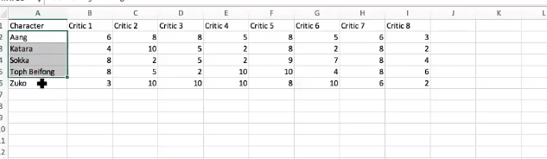

This is kind of two dimentional array

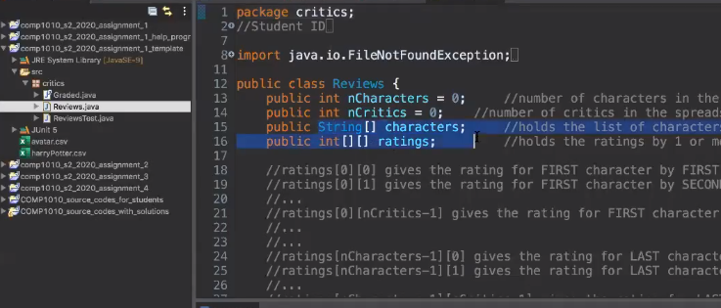

There name is stored in String array

And

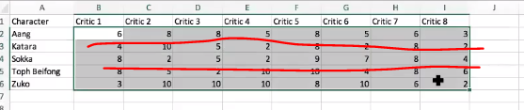

Each tuple is the sub array

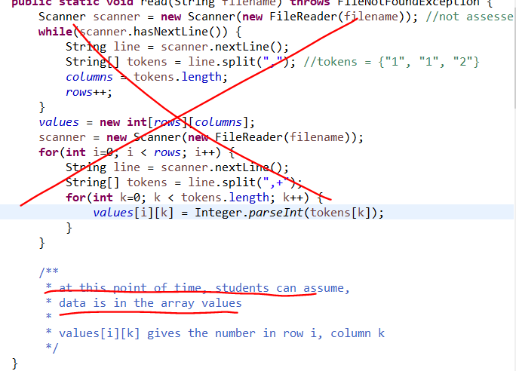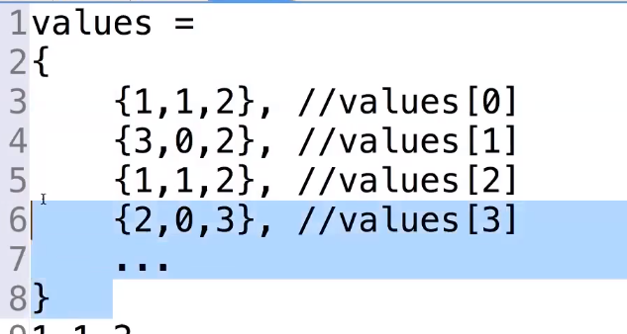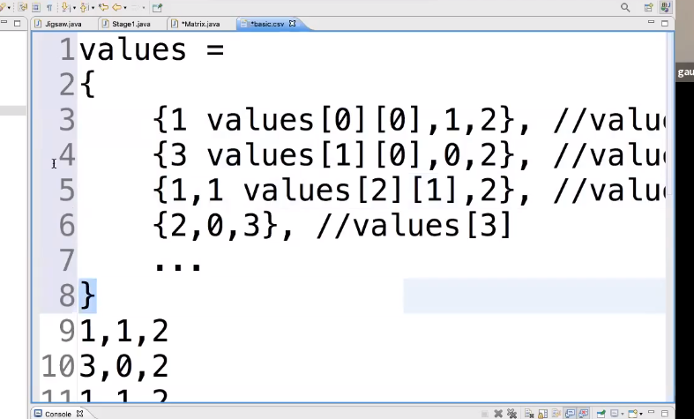

Values [i][k] gives the number in row I, column k

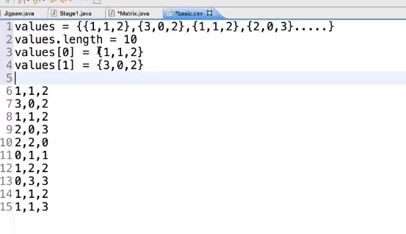

Valuses.length => row의 개수

Value[0].length > row 안의 원소들의 길이

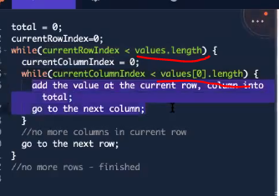

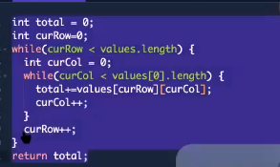

/\*\* + enter will make 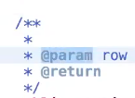this

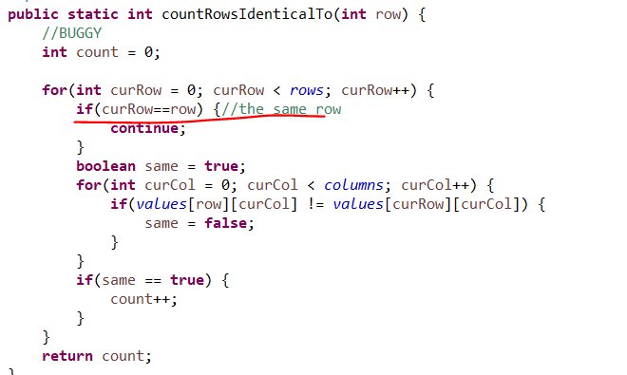

Skip the rest of the iteration of the inner-most loop

Or you can solve it like

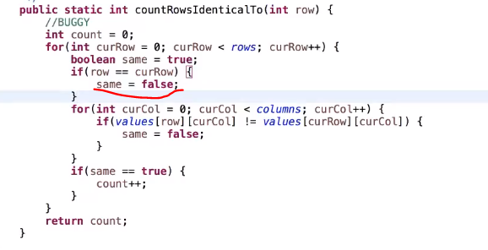

This as well

Or just -1 the count after.

Can you math library(prefer don’t use because there is only one method that math can be used)/ arraylist (no)

Junit test

If you want to do the junit test

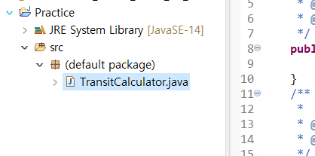

Right click the java file>select new > junit test case>

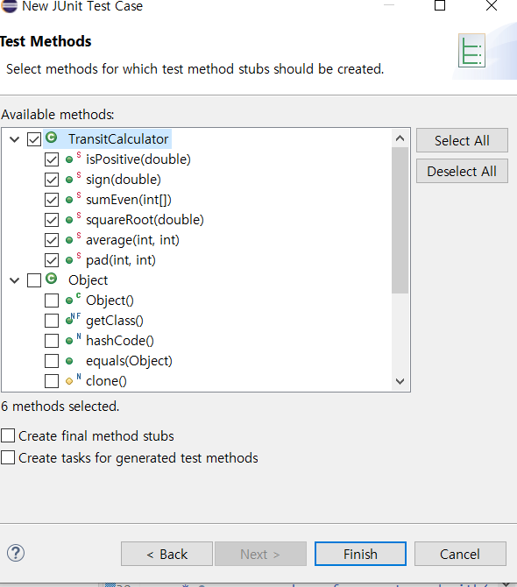

Select all that you want to test

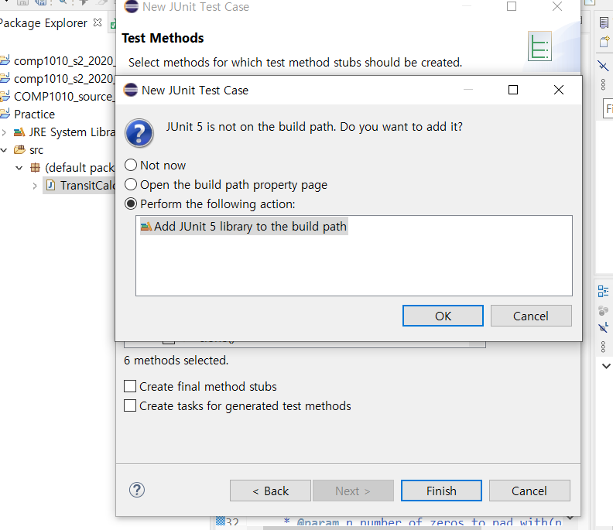

Then you can find test file in the package

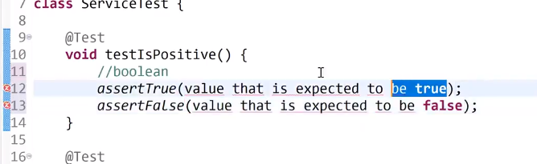

We can use assertTrue or assertFalse from now

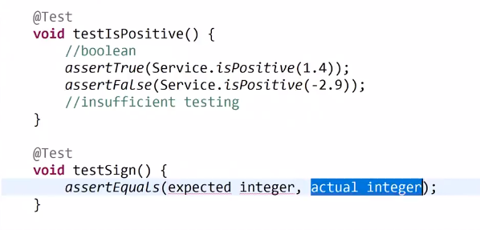

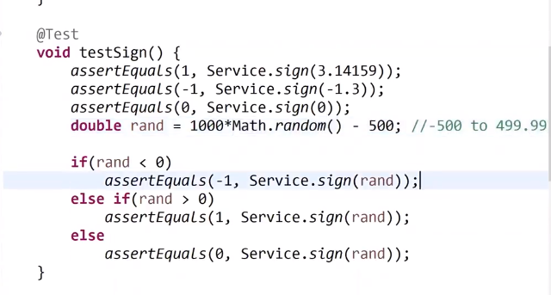

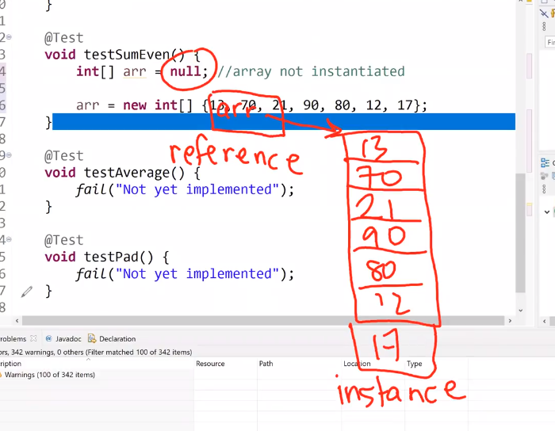

Array is about the reference

When you copying array it means you copy the address of array.

It is reference copy not instance copy.

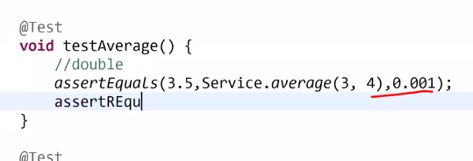

* 1. means tolerance

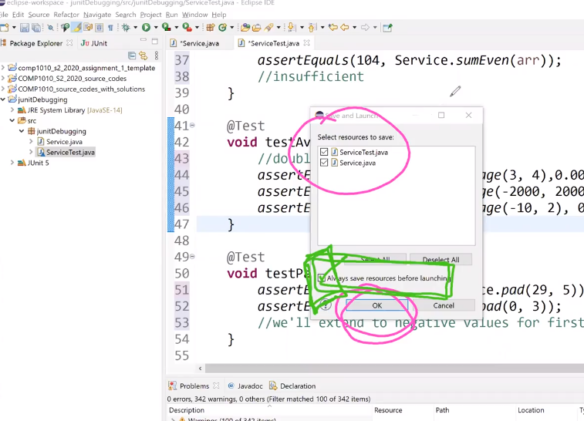

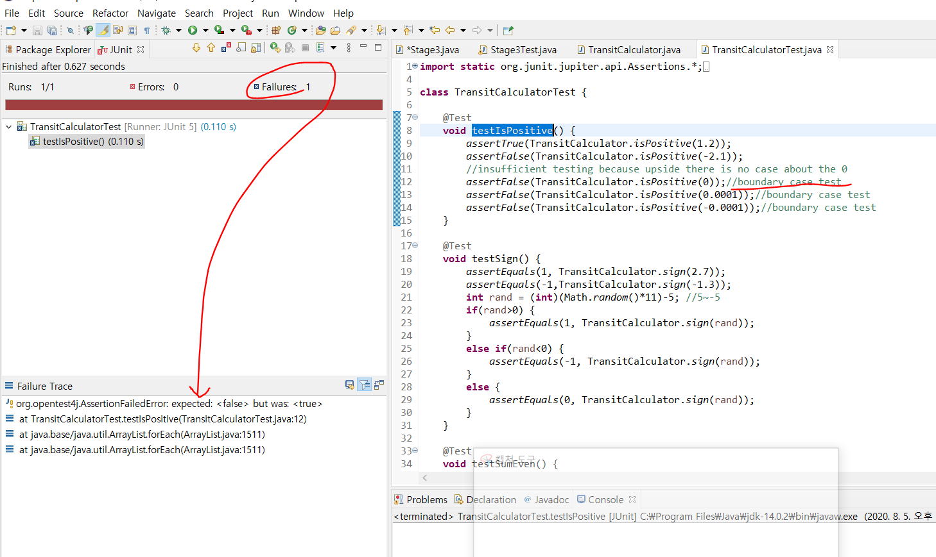

When you have the boundary testing then it is sufficient test now

And if you found the error or failure you should look at there

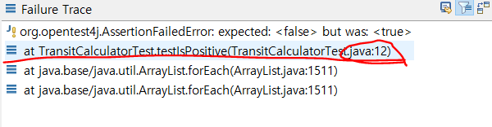

Second line is important because it will tell you where you can find the error

It means before is okay

12 line is the first case that fails from the top

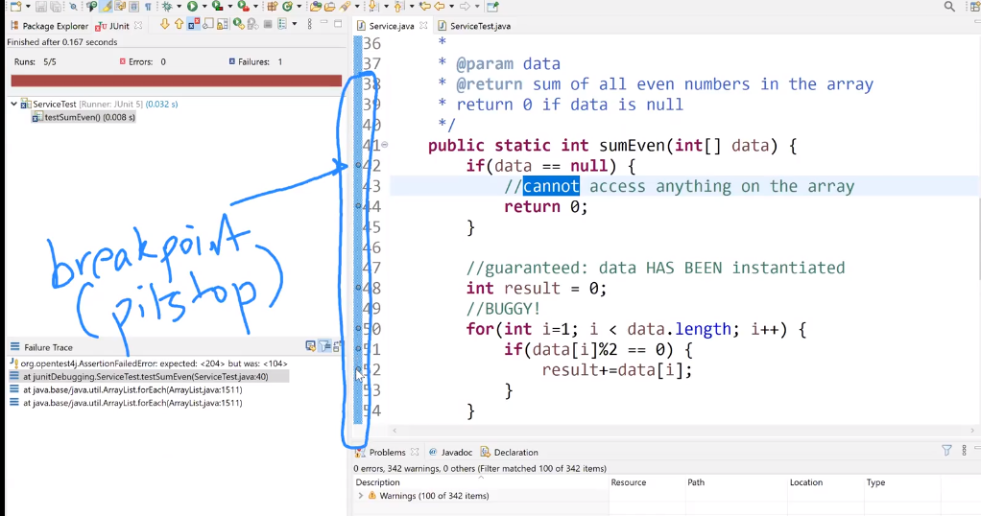

That can control the points that we run the code

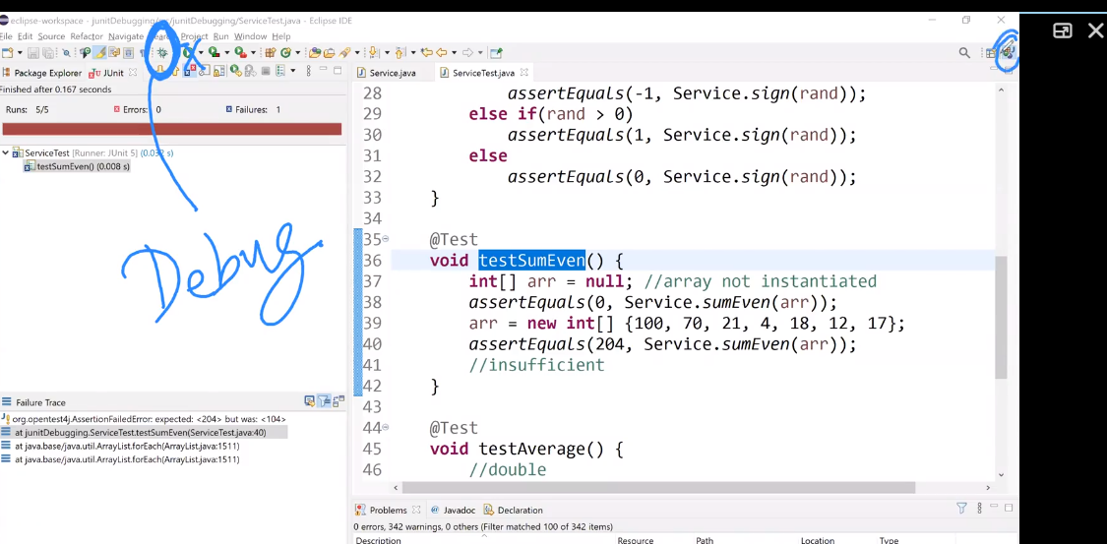

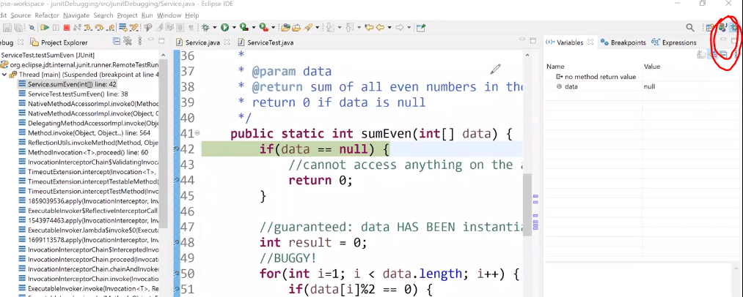

We are now in the debug perspective now

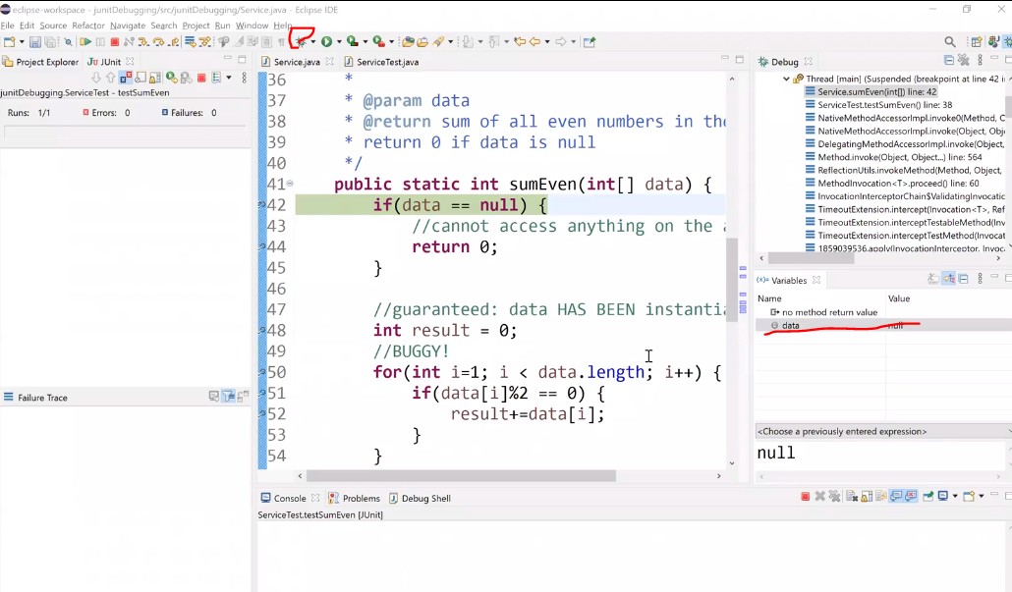

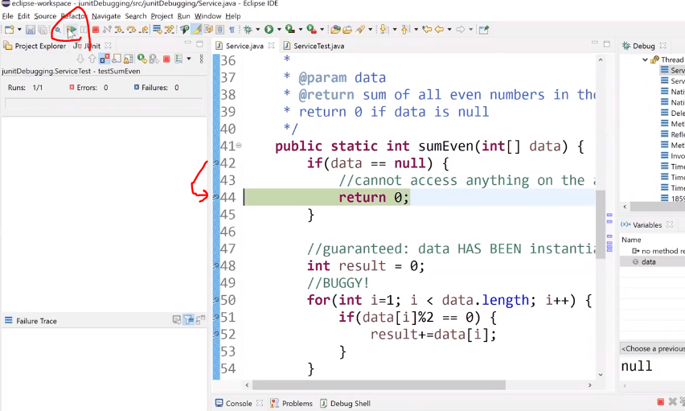

If you click resume it will debug the next break point

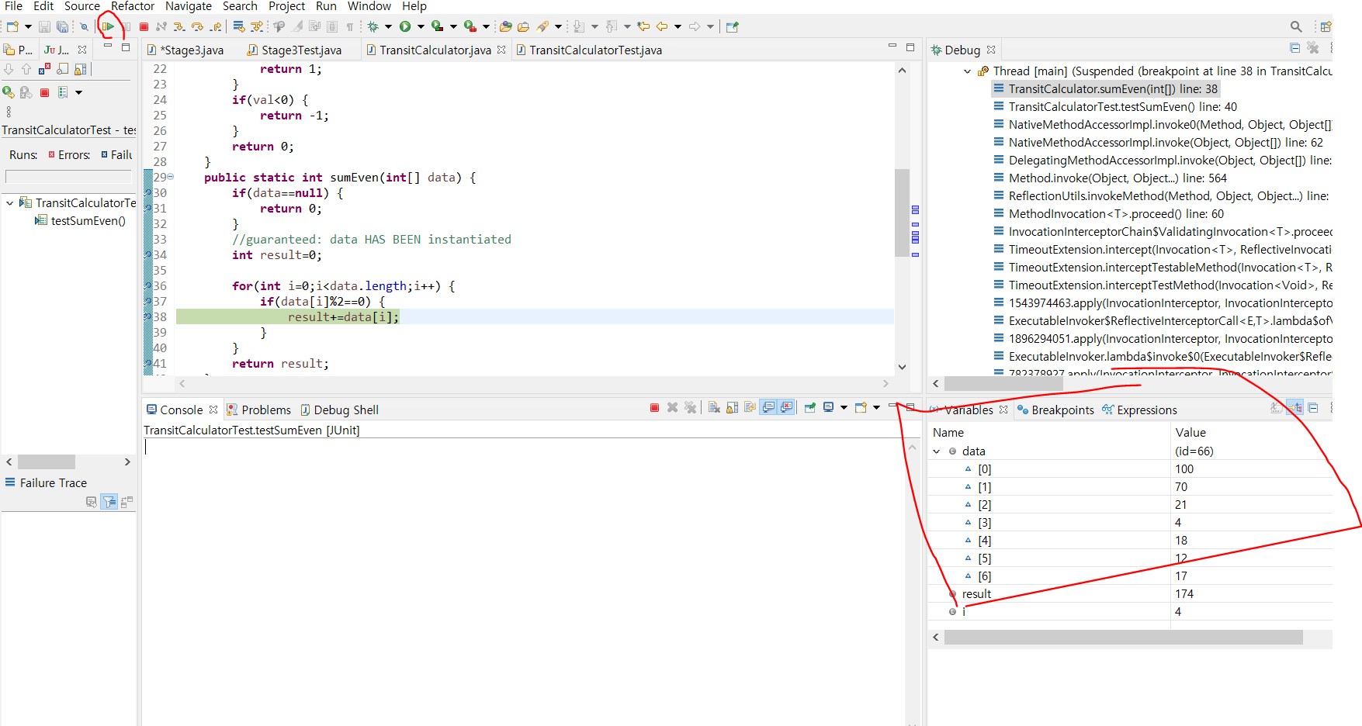

Assignment 2,3,4 some method won’t give the junit test so we need to create our own

Muti-dimensional array

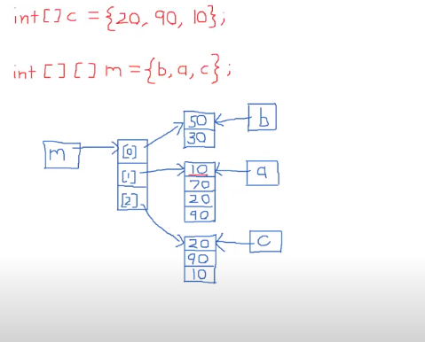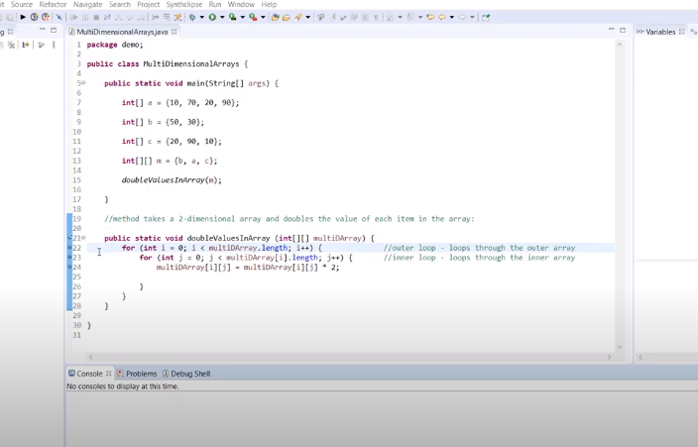

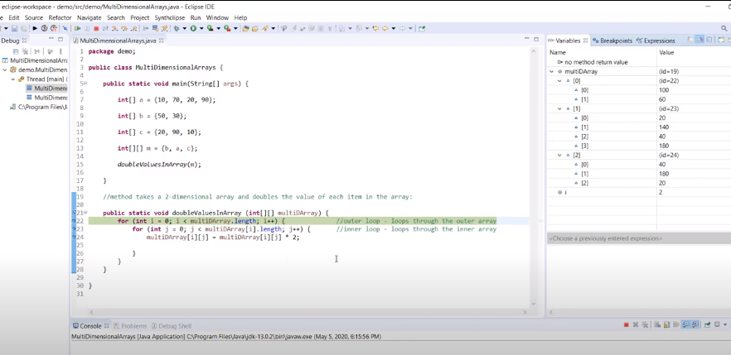

<https://starkying.tistory.com/entry/Bubble-Sort-%EB%B2%84%EB%B8%94-%EC%A0%95%EB%A0%AC-Selection-Sort-%EC%84%A0%ED%83%9D-%EC%A0%95%EB%A0%AC>

bubble sort and selection sort

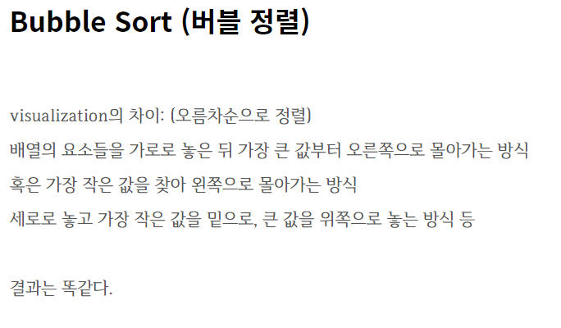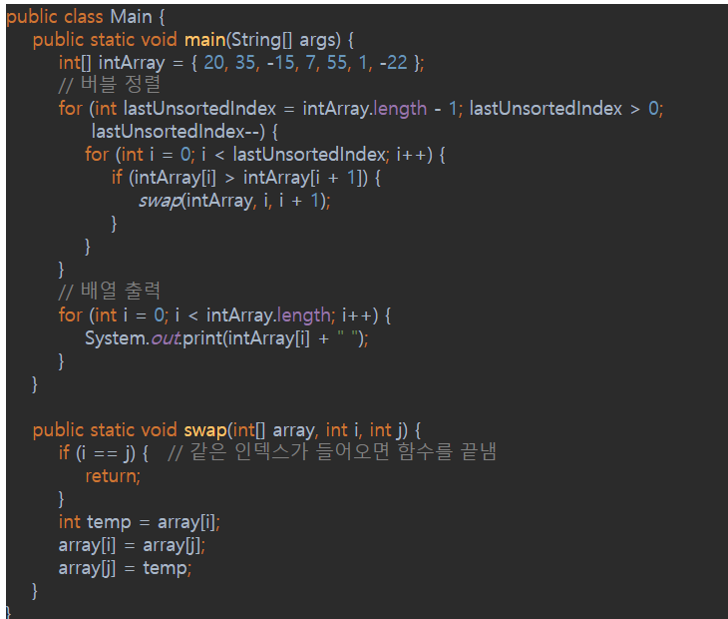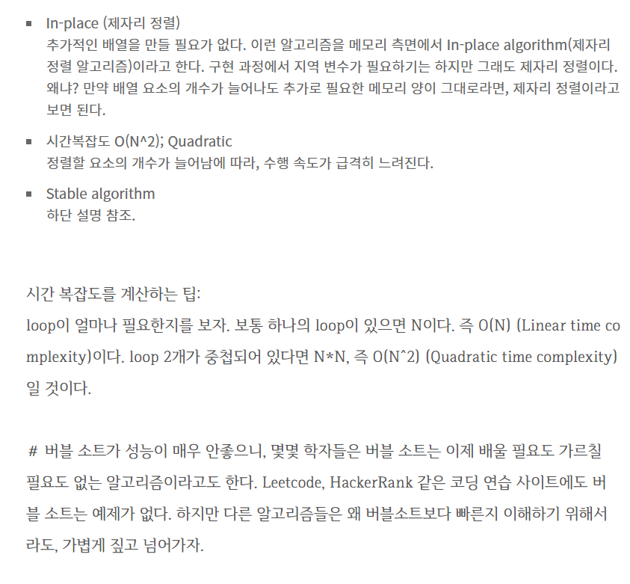

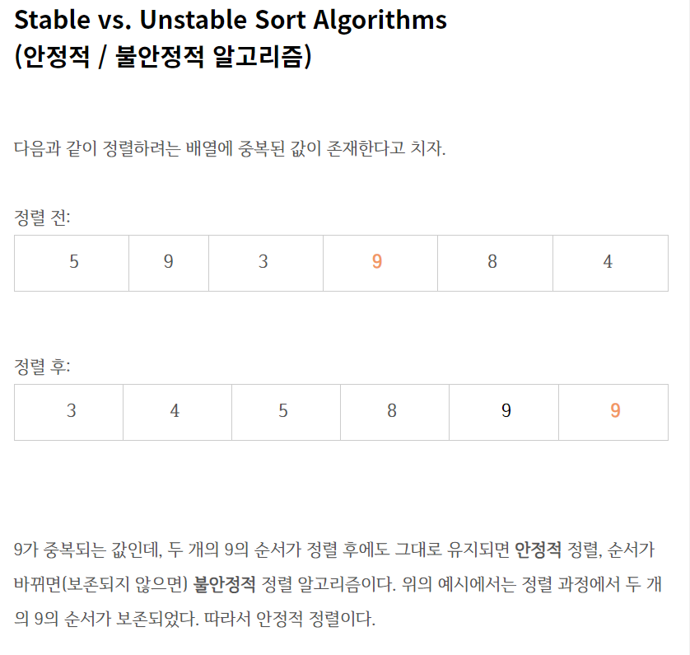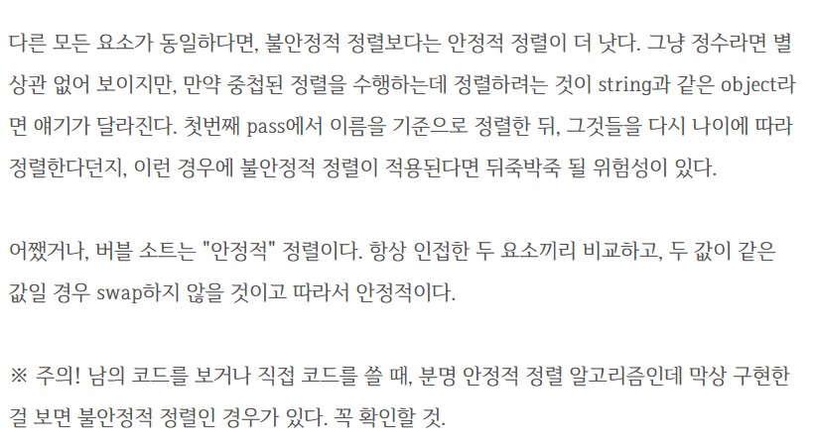

Stable when it is from low to high(not high to low)

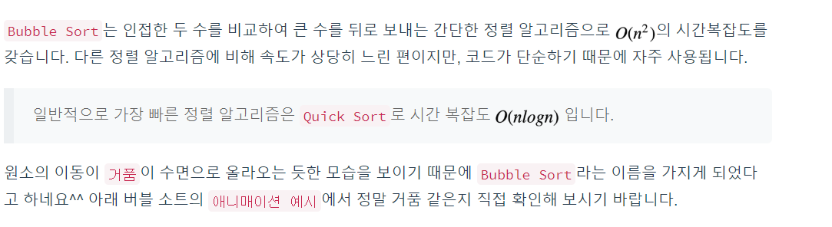

<https://bowbowbow.tistory.com/10>

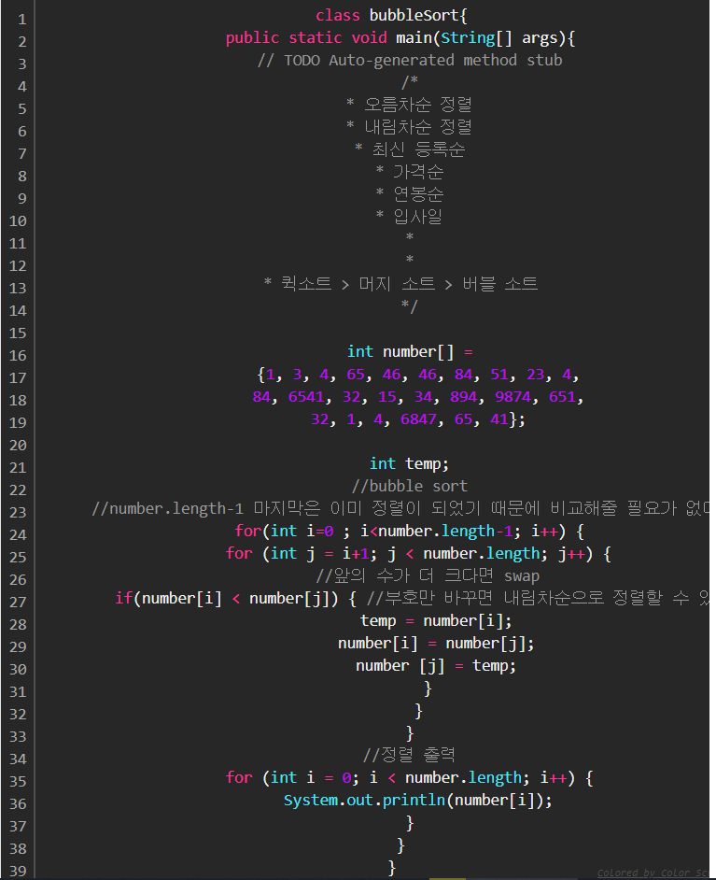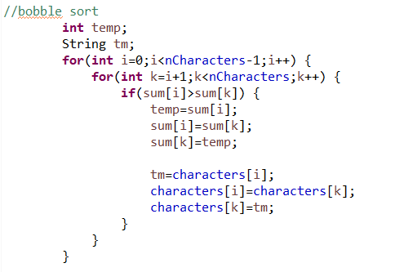

Low to high

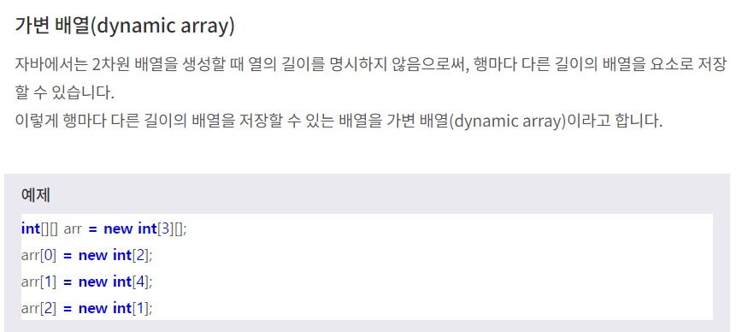

Bobble sort / 마지소트랑 퀵소트도 공부하기